

UNIVERSITY OF GHANA

**UNIVERSITY OF GHANA**

(All rights reserved)

**Automatic Agricultural Spraying Robot**

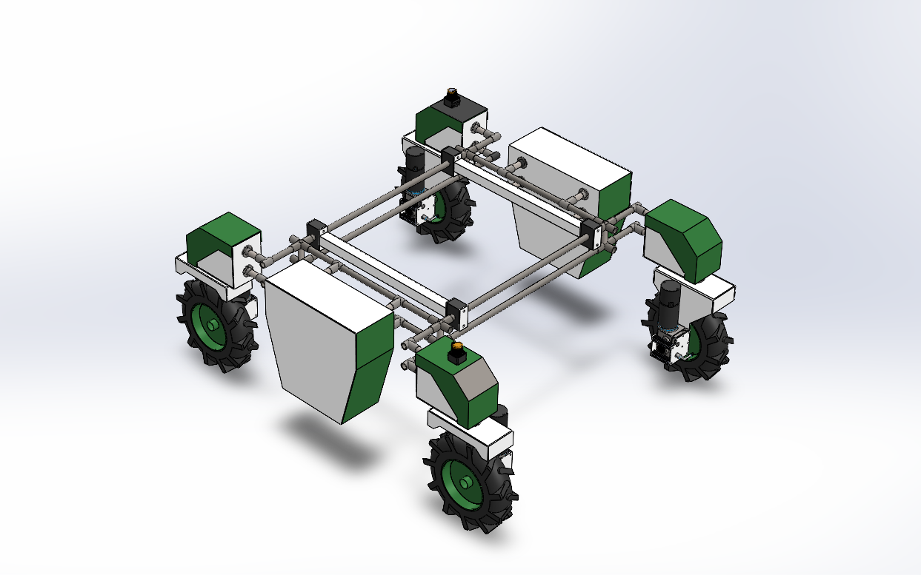

**TABLE OF CONTENTS**

Contents

**Automatic Agricultural Spraying Robot with Smart Decision Making** **1**

**Abstract……………………………………………………………………………………………………………………………………………3**

**Introduction…………………………………………………………………………………………………………………………………….4**

**Background…………………………………………………………………………………………………………………………….……5-6**

**Problem Definition………………………………………………………………………………………………………………………….6**

**Planning……………………………………………………………………………………………………………………………………….6-7**

**Functions and Designs………………………………………………………………………………………………………………..8-10**

**Alternative Solution………………………………………………………………………………………………………………....10-12**

**Evaluation Criteria…………………………………………………………………………………………………………………….12-13**

**Decision (Evaluation) Matrix…………………………………………………………………………………………………….13**

**Final Design Analysis………………………………………………………………………………………………………………..14**

**Major Components…………………………………………………………………………………………………………………..15**

**CAD Model of Final Design………………………………………………………………………………………………………..15**

**Analysis (Analytical/Numerical)…………………………………………………………………………………………………16**

**Bill of Materials (BoM)………………………………………………………………………………………………………………17**

**Conclusions and Future Tasks…………………………………………………………………………………………………..18**

**References……………………………………………………………………………………………………………….……………….19**

**Group 24**

**GROUP MEMBERS**

1. Gilbert Nketia- Biomedical Engineering 10978665

2. Ampofo Kissiwaa- Food Processing Engineering

3. Hammond Dillan- Computer Engineering 10952785

4. Sarpong Jacqueline Ofori- Food Processing Engineering 10972647

5. Acheampong Evans- Computer Engineering 10987644

6. Asamoah Maxwell- Biomedical Engineering 10977570

# **Automatic Agricultural Spraying Robot with Smart Decision Making**

**ABSTRACT**

The responsibility of controlling and managing the plant growth from early-stage to mature harvest stage involves monitoring and identification of plant diseases, controlled irrigation and controlled use of fertilizers and chemicals. The proposed work explores the technology of wireless sensors for remote real-time monitoring of vital farm parameters like humidity, environmental temperature and moisture content of the soil. We also employ the technique of image processing for vision-based automatic disease detection on plant leaves. Thus, this paper vigorously describes the design and construction of an autonomous mobile robot featuring plant disease detection, growth monitoring and spraying mechanism for chemicals, fertilizer and water to apply in agriculture or plant nursery. To realize this work we provide a compact, portable and well-founded platform that can survey the farmland automatically and also can identify the disease and can examine the growth of the plant and accordingly spray chemicals, fertilizer and water to the plant. This approach will help farmers make the right decisions by providing real-time information about the plant and its environment using fundamental principles of the internet, Sensor technology and Image processing. [1]

**INTRODUCTION**

In agriculture, the experience of the farmer is valuable. By trying to automate tasks  
that are traditionally performed by farmers, replacing them with autonomous robots,  
discards all that experience. In addition, trying to create autonomous robots that work  
in the field is particularly challenging, because the robots are subject to unpredictable  
environmental effects that may impair platform and perceptual capabilities. Autonomous robots in agriculture, where the platform and perceptual affordances are impaired, are often less successful in dealing with dangerous and complex tasks than  
in more structured, industrial settings (Edan, 1995; Thrun, 2004).

Introducing semi-automatic teleoperation of an agricultural robotic system can enable  
improved performance, overcoming the complexity that current autonomous robots  
face due to the dynamic and unstructured agriculture environment. Therefore, by  
using an automated robot, we leverage the farmers’ knowledge and experience while  
keeping them safe, away from the adverse conditions of the field, and we also help the robot manages the unpredictability of the environment in the field.  
In recent years, interactions styles such as virtual, mixed and augmented reality,  
tangible interaction, ubiquitous and pervasive interaction, context-aware computing,  
handheld or mobile interactions are becoming more popular. We believe that these new Reality-based interaction styles may offer new opportunities to how we interact with a robot to perform agricultural tasks.  
In this project, we describe the construction of such a teleoperated agricultural robot   
a sprayer that is controlled through a reality-based interaction interface. The robotic  
the platform allows farmers to remotely spray the plants in the field, thus leveraging their  
knowledge, and also protecting them from the adverse conditions of working in the  
field. [3]

**Background**

Spraying is a common task in agriculture that relies on chemical product use. Although  
these products are efficient, they leave chemical residues in the soil, decreasing soil fertility  
and the diversity of plants.  
Precision spraying is a method that reduces chemical losses. This method controls  
the number of chemicals distributed across the field according to specific characteristics.  
For more than two decades, studies have been carried out to contribute to precision  
spraying today. The first of these works began by investigating the effects of applying  
spatially variable herbicide doses. Later, the concept of precision spraying evolved  
to protection treatments directly applied on crop plants, where the amount of insecticide  
applied depends on factors such as foliage shape and volume.  
To improve the perception of these systems, grape clusters and foliage detection  
algorithms were constructed to guide the selected application of hormones to fruit and  
chemical application to foliage.  
In 2015, an automatically controlled sprayer was developed. The system uses ultra-  
sonic sensors to determine variations in the canopy structure and adjust valve opening to  
implement the variable-rate application. This application was achieved through three nozzles  
mounted at different heights on a vertical mast for orchard tree-spraying.  
The first study using an automatic selection system for spraying diseases in specialty  
crops were conducted in 2016. A robot capable of detecting and spraying from 85% to 100%  
of the diseased area and reducing the chemical use from 65% to 85% was developed.  
A new technique for a close-range precision spraying process in vineyards was evaluated. An air-assisted precision spraying and effector was presented, and the percentage of  
the spray coverage and the number of droplet impacts were evaluated. The results showed  
that the leaves’ front side’s spraying was good, but on the backside, the spraying was  
limited [4]

**Problem Definition**

Currently, spray operation is based on sprayers carried on the person’s back (manual)  
or, where possible, using a small tractor-based system equipped with air blast sprayers.  
Both current solutions have significant shortcomings. Manual spraying struggles with the  
lack of human resources in the region available to perform a heavy and non-ergonomic operation. The use of tractors has low spraying efficiency due to off-target and soil compaction  
problems.[4]

**PLANNING**

**Tasks and Subtasks**

A technical-economic analysis was conducted on spraying techniques with different control levels: an air-blast sprayer, an on-off nozzle switching sprayer, and a canopy-optimized distribution sprayer. The results showed that the larger the area to be treated, the higher the adopted technology’s level of precision should be. This analysis also showed that using a robotic platform produces chemical and labour savings. To make these tasks more efficient and intelligent, recognizing crops and weeds is an important task that can be achieved through image processing techniques. Some techniques differentiate crops and weeds from the soil first and then try to classify plants as crops or weeds based on their shape, texture, and colour properties. Recently, a machine learning-based vision system was developed to detect weeds and crops. Based on this, the plant canopy size is calculated and sent to a microcontroller that controls the flow rate of the agrochemical. Vegetation indices are often used in these perception systems to improve their performance. These are important indicators of the health and yield of crops. The system developed in this work has significant advantages: the robustness to work on rugged terrain and being completely electric, which is advantageous for the environment and allows more efficient control of the system compared with sprayers based on other techniques. [6]

**Gantt Chart**

|  |  |  |  |  |  |
| --- | --- | --- | --- | --- | --- |
| Task name | 28th April | 4th May | 10th May | 20th May | 28th May |
| Planning |  |  |  |  |  |
| Research |  |  |  |  |  |
| Design |  |  |  |  |  |
| Implementation |  |  |  |  |  |
| Follow up |  |  |  |  |  |

**Block Diagram**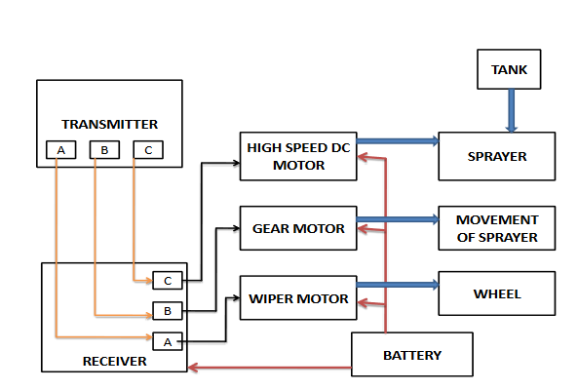

**Requirements**

1. **Functions and Designs**

**Design A -Automatic Agricultural Spraying Robot**

The overall design of the autonomous Argo-chemical spraying robot is illustrated in Fig. 1. The design is done using SOLIDWORKS software and the development of the autonomous chemical (chemicals, weedicides and herbicides) spraying system based on the design. The specification of the autonomous chemical spraying robot is shown in Table I. The dimension of the autonomous chemical spraying robot is determined to be 122 cm (2 feet) because the size of the row for the fertigation farm is about 3 feet. In addition, the height autonomous chemical spraying robot is determined to be 2 m because the normal height of the chili fertigation farm is below 2 m. The system overview for the autonomous chemical spraying system is illustrated in Fig. 2 shows an overall connection between two different systems that will be combined inside of the autonomous chemical spraying robot. The development of the autonomous Argo-chemical sprayer prototype consists of two parts where the navigation system and the spraying system. The interconnection between the selected components in the designed robot is crucial and plays a major role to make sure the robot function as desired. Misconnection between the electronic components can lead to malfunction of the designed system thus deviating the operation from achieving the project objective. [5]



Figure I.

Table I.

|  |  |
| --- | --- |
| Item | Specification |
| Robot dimension | 122 cm x 122cm x 200 cm (L X W X H) |
| Robot weight | 12 kg without payload |
| Drive system | 4- wheeled drive system |
| Power supply | 24V DC lead-acid rechargeable battery |
| Ground clearance | 12 cm from the ground |
| Payload | Max: 20 kg |

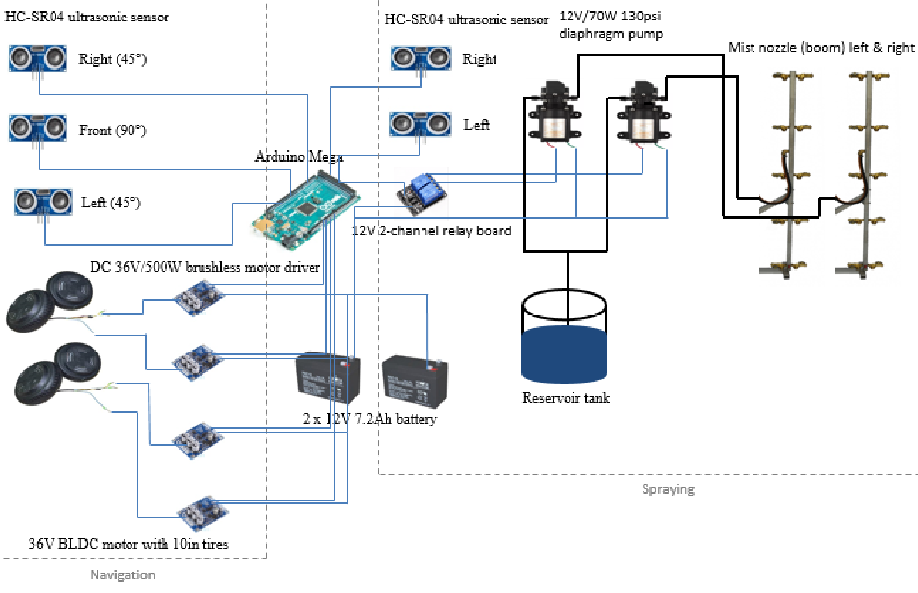

Figure 2. System Overview of Acceleration-based Movement Detection

1. **Navigation System**

The navigation system consists of some ultrasonic sensors, a microcontroller, four units of brushless DC motor with a motor driver for each motor, and a 24 V DC rechargeable battery. The microcontroller is the heart of the system where the designer can write and load the program into it to control the sequence and operation of the peripheral that is connected to its pin 12 in the microcontroller. Using the programming software which has been predetermined, the coding will be uploaded into the microcontroller which will determine how the designed robot will be operated. In this project, the Arduino Mega 2560 will be used as shown in Fig. 2 because it has adequate I/O pins for input and output either analogue or digital I/O.

1. **Spraying System**

While the microcontroller executes the condition in the navigation part, the condition for the spraying system also will be considered. As the autonomous chemical spraying robot needs to be able to execute both of the operations simultaneously, the sequence inside of the programming code plays a critical role in the designed project. The main components consist of the spraying system are a reservoir tank, chemical pump, 2-channel relay circuit, tube and some mist nozzles for spraying under the crop leaves. The reservoir tank which is used in the autonomous chemical spraying robot will be filled with chemical incapacity of 10L although the  
maximum of 20 kg of the payload can be carried out.

To supply the chemical from the reservoir tank to the end of the spraying nozzle, the use of the 12V/ 70W 130 psi diaphragm chemical pump is selected as shown in Fig. 2. The selection of a chemical pump is crucial because the pump needs to be eligible to push the chemical out with desired pressure. With the help of the pump, spraying can be directly allocated to the desired targeted plants, especially under the crop leaves, by only giving electrical input to the pump which procured is by sensors upon detection of the plants. [8]

**ALTERNATIVE DESIGN/SOLUTION**

**Design B- Precision Robotic Sprayer (PRYSM)**

To accomplish Precision Robotic Sprayer (PRYSM), features, we had to organize the hardware to avoid interference between sensors and actuators. The planned general organization for the PRYSM robot is presented in Figure II. The sensing, communication, and processing units are stored on a tower in front of the robot. For localization, mapping, perception, and safety, a light detection and ranging (LiDAR) sensor is placed on the top of this tower to ensure that they have observability of 180° on the robot’s front. The Global Navigation Satellite System (GNSS) antenna improves the localization precision and is placed on the top of the tower. The sprayer is placed in a mast installed on one robot’s back, far away from the sensors to avoid water projection into the sensors. The water pumps and sprayer power are stored below the sprayer tank. The sprayer controller and sensing sensors are placed on the robot front to avoid exposure to water and increase the vine canopy visibility. [9]

**Figure II**.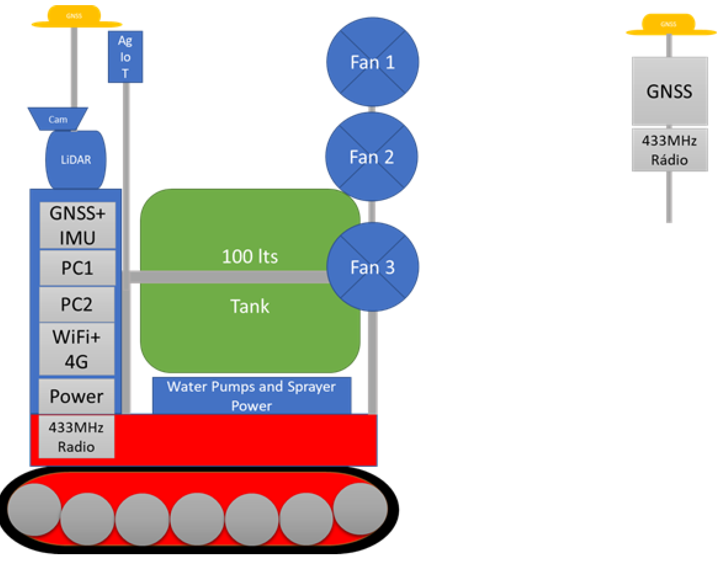

## Electric Sprayer Description: PRYSM

## We propose a fully electrical PRYSM sprayer using a centrifugal principle. The structure of the sprayer, the PRYSM sprayer, consists of three spray drums and a fertilizer tank. Each drum comprises 3D models and an aluminium plate on the side (Figure III.). These models are used to provide structure and fix the motors and the fertilizer pipe. Both the drums and these models used to fix the motors are fixed on an aluminium profile. This fixing can be performed at different heights according to the specific application. The fertilizer tank has a capacity of 100 L and is fixed in a stainless-steel tube structure. [9]

## 

**Figure III**.

**Evaluation Criteria**

These include;

Operation Cost: The ongoing expenses incurred from the normal day-to-day of running a business. These include

Reliability: how consistently a method measures something. If the same result can be consistently achieved by using the same methods under the same circumstances, the measurement is considered reliable

Maintenance Cost: costs incurred when performing routine actions to keep an asset in its original condition.

Ecological factors: Ecological factors are environmental variables that impact organisms and contribute to their characteristic modes of behaviour.

Safety: The safety of the spraying robot is key as it protects the unsuspecting small-scale farmer from various injuries arising from the operation of the robot.

Initial cost: This includes the automated sprayer’s purchase price plus any costs directly attributable to bringing the asset to the location and condition necessary for it to be capable of use in the manner intended.

Simplicity: The automated spraying robot is carefully constructed to provide an easy understanding to the uneducated farmer.

Assembly time: The total elapsed time taken to complete the automated agricultural sprayer project.

Aesthetics: it simply refers to the product’s design and overall look. The first impression of a product is often visual, making aesthetics very important. As well as aesthetics, factors that can influence a user's opinion of a product include colour and sound.

DECISION (EVALUATION) MATRIX

|  |  |  |  |  |  |
| --- | --- | --- | --- | --- | --- |
| **Criteria** | **Weight** | **Design A**  **r wj(rj-4)** |  | **Design B**  **r wj(rj-4)** |  |
| Ease of Operation | W=0.4 | 5 +0.4 |  | 2 -0.4 |  |
| Assembly Time | 0.3 | 4 +0.3 |  | 1 -0.3 |  |
| Aesthetics | 0.2 | 3 +0.2 |  | 4 +0.2 |  |
| Operation Cost | 0.2 | 4 +0.2 |  | 2 -0.2 |  |
| Safety | 0.4 | 4 +0.4 |  | 3 0 |  |
| **Total score Cwi =∑wi (ri-3)** |  | **CwA = 1.5** |  | **CwB = -0.7** |  |

**Conclusion:** If the given weights are considered, then Design A is more favourable than Design B.

**ANALYSIS OF FINAL DESIGN (DESIGN A)**

Automatic agricultural spraying robots could help small-scale farmers in Ghana carry out a host of field and yard tasks, including mowing, pellet spreading and spraying.

The fully electric R150-ATJ platform has a four-wheel-drive system and a turning diameter of just 0.7m, thanks to its skid-steer-style movement.

The 48v lithium batteries offer a 30min runtime with two batteries to keep the robot running continuously, with just a 15min recharge time from empty and the ability to run in the dark, 24 hours a day.

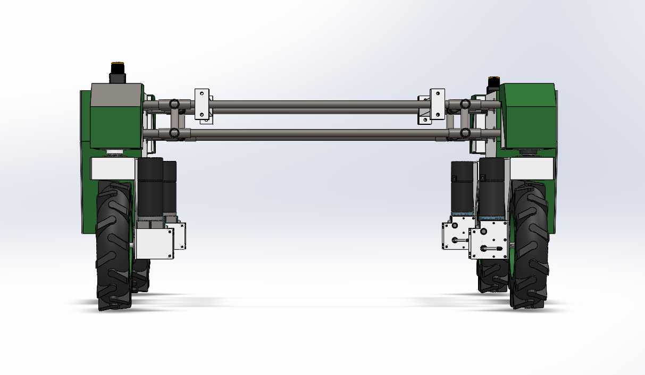

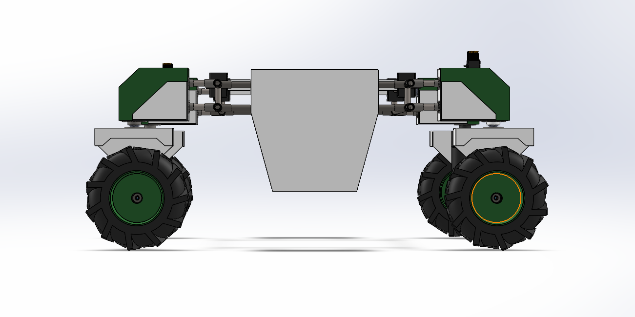

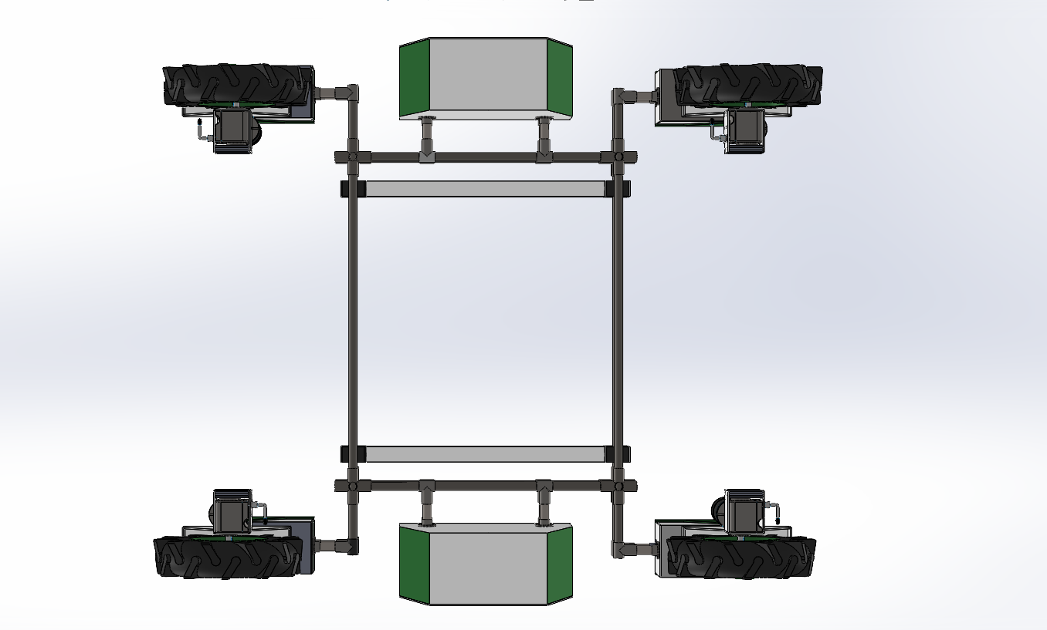



**MAJOR COMPONENTS**

10L tank capacity load capacity   
12M (39ft) max spray width High-speed charging   
4.8L (1.27gal) per min max flow rate 12.4 acres per hour  
4 hours of continuous operations Modular in design  
Optional payload systems High-strength integration steel frame  
Roll cage to improve body strength High-speed jet spraying  
Easy Palm Control Powerful Momentum  
Automated delivery High-performance brushless motors  
Four-wheel drive Electric parking brake system

**FINAL DESIGN (CAD MODEL)**

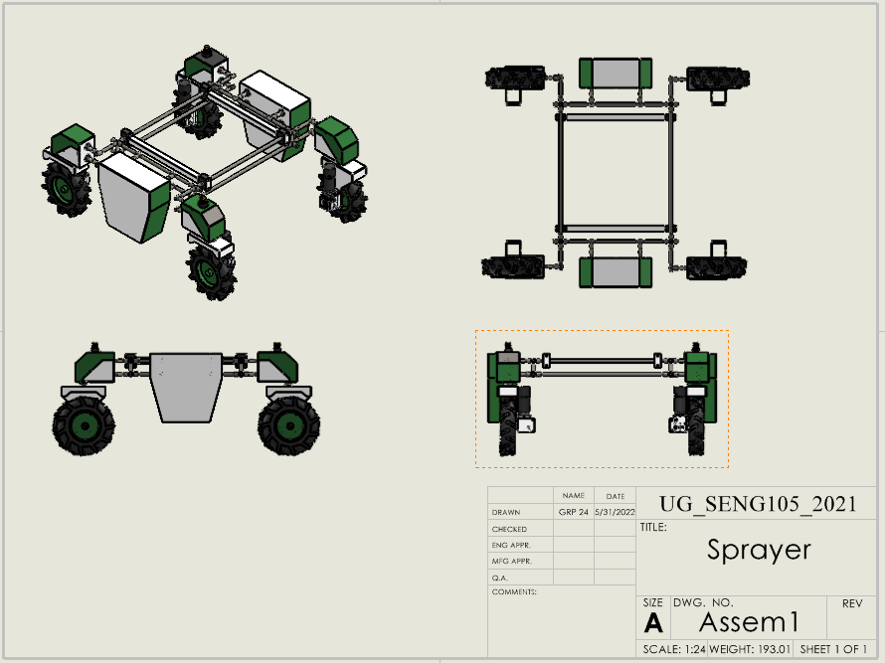

**ANALYSIS (ANALYTICAL/NUMERICAL)**

All the measurement data obtained from the ultrasonic sensor on the autonomous chemical sprayer robot in this experiment are recorded and the moving path of the autonomous chemical sprayer robot is plotted on the graph as shown in Fig. 13. The graph will be divided into three graphs that represent the front, right and left sensor distance versus the distance of the path taken mutually. The experimental method which is applied has been referred from previous works  
conducted as shown in Fig. 13. the starting point for the autonomous chemical sprayer robot started at 3000 cm from the end of the junction. So, the max detection from the front sensor should be below 300 cm which will become closer as the robot moves forward and farther as the robot moves backwards. In Fig. 13, only at the point of conditions occurred will be shown as the data was too many to display such as in here it got starting, detection, stopping, turning and ending point in the highlighted colour which is orange for starting point of the detection, blue for stop detection point, red for an actual store stopping point, green for start left-turning point and grey for ending point of the detection. The developed autonomous chemical sprayer robot was tested to stop at the point of detection by the front sensor which is below 150 cm but due to BLDC motor cannot instantaneously stop its rotation due to its characteristic of being brushless that does not have a braking system and also cause by inertia acts upon it, there will be an overshoot of the autonomous chemical sprayer robot movement before it was fully stopped at distance 305.03 cm. After fully stopping, the robot will take a backward step with a delay of y 5 s until it reaches 227.28 cm from the stopping point. Then, at this point, the value of distance for the left and the right sensor was compared by the given condition in programming code based on which distance was the farthest to detect an obstacle whether the left or right sensor. If the left sensor distance was highest means farther the rom obstacle compared to the right one, the function for turning left will be called out programs looping then executed or otherwise. However, since the autonomous chemical sprayer robot was tested out to take a left turn in this experiment, the measurement data between left sensor distance is 233.9 cm and right sensor distance, 64.44 cm at this point. Later, the motor will manipulate its direction through the gate driver in the motor driver to take a left turn and basically, the method used to change the heading direction of the autonomous chemical sprayer robot was based on the combination of motor drive with the differential drive when to take left direction, the motor 1 and 3 will turn backwards with PWM speed of 80, while motor 2 and 4 will turn forward with PWM speed of 200. Thus, this could allow the autonomous chemical sprayer robot to have some sort of gliding effect during changing directions. The operation for right-turning can be vice versa to left turning in terms of motor direction turning and its speed. After the left turn a with 90° curve, the robot will stop at a distance of 717.91 cm due to overshoot during turning and then take a backward step once again for 5 s.

Fig. 13. Measurement Data from the Ultrasonic Sensor for Autonomous  
Chemical Sprayer Robot.

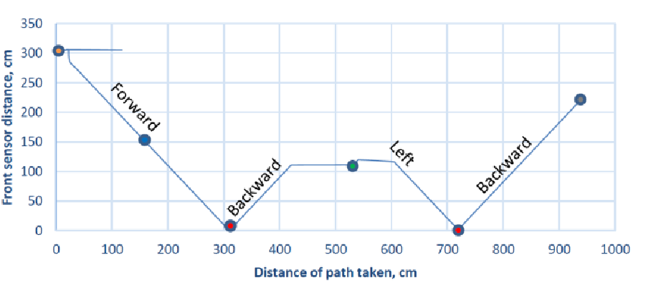

(a) The Distance of Path Taken by Robot vs Front Sensor Distance Detection.

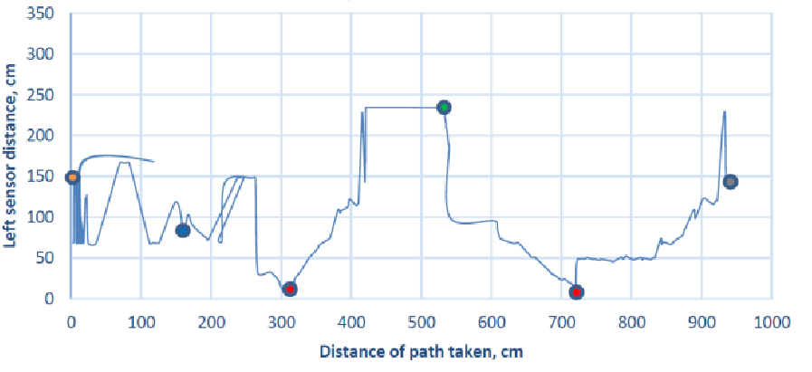

(b) The Distance of Path Taken by Robot vs Left Sensor Distance Detection.

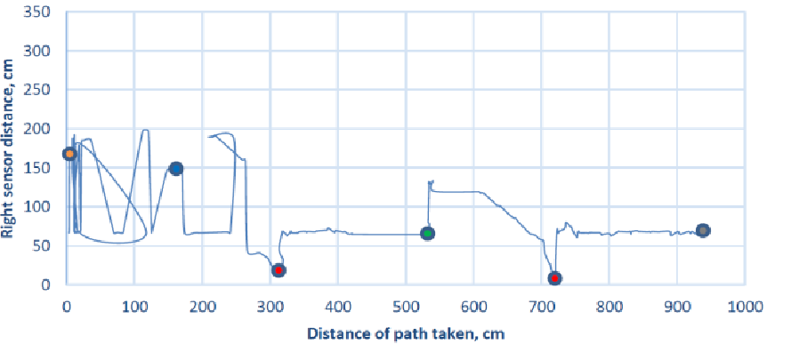

(c) The Distance of Path Taken by Robot vs Left Sensor Distance Detection

**BILL OF MATERIALS (BoM)**

|  |  |  |  |  |  |  |
| --- | --- | --- | --- | --- | --- | --- |
| Automatic | Agricultural | Spraying | Robot | 122 cm x | 122cm x | 122cm |
| BoM level | Part # | Description | Qty | Units | Unit cost | Cost |
| 1 | 654 | 10L tank capacity | 1 | Litre | Gh¢50.00 | Gh¢50.00 |
| 3 | 231 | Payload systems | 1 | 1 | Gh¢10.00 | Gh¢10.00 |
| 1 |  | Roll cage | 1 | metre | Gh¢15.00 | Gh¢15.00 |
| 2 | 879 | Easy Palm Control | 1 | 1 | Gh¢45.00 | Gh¢45.00 |
| 1 | 251 | Automated delivery system | 1 | 1 | Gh¢35.00 | Gh¢35.00 |
| 2 | 111 | Four-wheel drive | 2 | 2 | Gh¢135.00 | Gh¢270.00 |
| 2 | 346 | Modular in design | 2 | 2 | Gh¢25.00 | Gh¢50.00 |
| 3 | 648 | High-strength integration steel frame | 4 | metre | Gh¢25.00 | Gh¢100.00 |
| 6 | 999 | High-performance brushless motors | 4 | 4 | Gh¢30.00 | Gh¢120.00 |
| 5 | 000 | Electric parking brake system | 2 | 2 | Gh¢70.00 | Gh¢140.00 |
|  |  | Total number of parts | 20 |  | Total Costs | Gh¢835.00 |

**CONCLUSIONS AND FUTURE TASKS**

In conclusion, designing and developing autonomous chemical spraying for a fertigation farm has been successfully conducted. All the subsystems such as navigation systems and spraying systems are included. Although the navigation part has been tested, the autonomous chemical sprayer robot can be self-navigating by turning at the junction by using the obstacles detection concept inside the fertigation farm. The ultrasonic sensors were used in the front of the sensor it was adjacently facing forward at 90° while the other two left and right were both facing forward with a deflection of 45°. The ultrasonic sensor could detect the obstacles and stop without hitting the obstacles, respectively. For future works, the spraying pressure of the autonomous chemical sprayer robot will be tested and the electronic circuits need a waterproof structure since the autonomous pastiche ide sprayer robot deals with a chemical which is fluid. Therefore, the isolation of the electronic component should be done well by separating each electronic component in the container box to prevent it from being damaged if flooding or leakage happened inside the robot. On the other hand, the pest monitoring system should be developed to be an auto-monitoring device while spraying the chemical. Thus, using the advanced version of automatic agro sprayers for agriculture would make the heavier tasks much easier. A world might be expected shortly that replaces the futile sprayers with the proficient automated Argo-sprayer.

**References**

[1] <https://link.springer.com/chapter/10.1007/978-3-319-47952-1_60> (2016, September 18) Abstract of the project.

[2] <https://hse-uav.com/product/r150-spraying-hauling-tractor/> Images of the Automatic Agricultural Spraying Robot.

[3] <https://www.researchgate.net/figure/The-agricultural-robot-sprayer_fig1_262535670> (May 2014) Introduction of the project.

[4] <https://mdpi-res.com/d_attachment/electronics/electronics-10-02061/article_deploy/electronics-10-02061.pdf?version=1629968545> (May 6, 2020) Background of the project.

[5] [https://thesai.org/Downloads/Volume11No2/Paper_69-Design_and_Development_of_Autonomous_Chemical_Sprayer.pdf](https://thesai.org/Downloads/Volume11No2/Paper_69-Design_and_Development_of_Autonomous_Pesticide_Sprayer.pdf) (November 11, 2020). Project requirements.

[6] <https://mdpi-res.com/d_attachment/electronics/electronics-10-02061/article_deploy/electronics-10-02061.pdf?version=1629968545> (July 5, 2021). Project plan.

[7] <https://thesai.org/Downloads/Volume11No2/Paper_69-Design_and_Development_of_Autonomous_Pesticide_Sprayer.pdf> (November 11, 2020). Figure 2. System Overview of Acceleration-based Movement Detection

[8] <https://thesai.org/Downloads/Volume11No2/Paper_69-Design_and_Development_of_Autonomous_Pesticide_Sprayer.pdf> (November 11, 2020).Detailed Design A description.

[9] <https://mdpi-res.com/d_attachment/electronics/electronics-10-02061/article_deploy/electronics-10-02061.pdf?version=1629968545> (June 3, 2018 ). A detailed description of Design B.

[10] <https://thesai.org/Downloads/Volume11No2/Paper_69-Design_and_Development_of_Autonomous_Pesticide_Sprayer.pdf> (November 11, 2020) Analysis and Results.

[11] ] <https://thesai.org/Downloads/Volume11No2/Paper_69-Design_and_Development_of_Autonomous_Pesticide_Sprayer.pdf> (November 11, 2020 ) Conclusions and Future Tasks.